LLM in Workforce: Knowledge Capture and Transfer
User Manual
——————————————————————————————————————————
Table of Contents:

- Requirements and Program Deployment/Setup 2
  - System/OS Package Requirements 2
  - Python Package Requirements 2
  - Other Technical Requirements 2
  - System Setup Instructions 3
  - OpenAI API Key Setup Instructions 3
- System Functionality 4
  - How Does This Work? 4
  - Main Features 4
- System Walkthrough 5
- Additional Possible Scenarios 7
  - Invalid File Input (Drag + Drop) 7
  - File Explorer Opened, No File Selected 9

Part 1 - Requirements and Program Deployment/Setup:

a. System/OS Package Requirements:
- Python: Install the latest version of Python from https://python.org. Verify Python is installed with python --version.
- FFmpeg: Install the latest version from https://ffmpeg.org, or use the Homebrew package manager. Verify FFmpeg is installed on your system with ffmpeg -version.
- Tkinter: Tkinter should already be included as a part of Python. However, to install Tkinter, use sudo apt-get install python3-tk. If that doesn’t work, try pip install tk. To verify installation of Tkinter, run python -m tkinter in the Terminal. If you see a GUI window popup, then Tkinter is installed on your system. (NOTE: Despite successful installation, you may see a warning in PyCharm saying "Package requirement 'tkinter' is not satisfied" — if the program still runs and displays a GUI window, you can safely ignore this warning.)

b. Python Package Requirements: To install all the below requirements, run pip install -r requirements.txt, or use pip install <package-name> for each package separately.
- ffmpeg-python: FFmpeg wrapper for Python. Ensure the FFmpeg package is installed on your system, see above.
- openai: The OpenAI client library to access the API.
- pydub: Used for audio processing, often requiring FFmpeg. Verify FFmpeg is installed, see above.
- markdown: Used for markdown file processing for page generation.
- tkinterdnd2: This is a drag-and-drop library for Tkinter.

c. Other Technical Requirements:
- Stable internet connection
- OpenAI API key
- Storage space: At least 2x the size of your input videos
- Minimum 8GB RAM recommended

d. System Setup Instructions:
- Clone this git repository to your local machine and set it up in the PyCharm IDE.
- Install Python and FFmpeg with the links above. Verify these have been installed.
- Ensure tkinter is installed on your system; if not then install it.
- Run pip install -r requirements.txt to install all Python package dependencies.
- Run python main.py to execute the program, or click the Play button in PyCharm with the run configuration set to main.py. The main page of the GUI should launch.

e. OpenAI API Key Setup instructions:

The OpenAI API key needs to be saved as an env variable on your machine. You can export an environment variable from the Terminal with the name OPENAI_API_KEY.

If that doesn’t work, then create a file named “.env” in the root folder of the cloned GitHub repository (it should be a hidden file or excluded with .gitignore). In the file, write the text OPENAI_API_KEY=<your-api-key-here>.

Then navigate to transcribe.py and replace the client = OpenAI() code statement with the following code block:

from dotenv import load_dotenv
import os

load_dotenv(dotenv_path=".env")
client = OpenAI(api_key=os.getenv("OPENAI_API_KEY"))

If you use this code snippet for a custom .env file in your repo, make sure to exclude these changes when making commits.

Part 2 - System Functionality:

a. How Does This Work?
- The user uploads a video about a robot in the Robotics Lab (can be a how-to video on how to use a robot, etc.)
- Upon confirmation, the system transcodes the video into an audio file, which is transcribed into a transcript with timestamps that match each spoken segment with its time in the video.
- The text is used to generate an HTML page of work instructions that outlines the video contents, with image placeholders where supplementary visual aids (i.e., keyframes from the video) should be inserted, with descriptors of what those keyframes should be.
- The transcription is analyzed for the correct time intervals to search for keyframes, using the placeholder texts from the HTML file.
- Images are extracted from the video file at the selected time intervals (from Step 4) at a rate of 1 FPS. Each set of images is saved in a separate temporary directory.
- Each set of images is analyzed using a binary search-like algorithm to select the best image (in terms of quality and accuracy, based on the placeholder text) and is saved in the output directory with the appropriate filename so the HTML page can automatically detect it.
- The user moves the generated HTML and image files outside of the output directory to another directory of their choice.

b. Main Features:
- Automated HTML Page Generation: The system automatically generates a documentation page of work instructions based on the video uploaded, with visual aids embedded. This works by transcoding the video to audio and transcribing the audio into text that is further analyzed for documentation generation.
- Easy Video Uploads: For intuitive usage, the user can drag and drop a video or select a video file from the system File Explorer rather than manually inputting the video name (i.e., from the CLI).
- Keyframe Selection Powered by AI: The OpenAI API automatically analyzes the video for keyframes to integrate in the work instructions, based on the context of the video.
- Support for Multiple Video Formats: The system supports any .mp4, .mov, .avi, and .mkv file of any duration.

Part 3 - System Walkthrough

- Select a video file to upload. Either drag and drop it in the drop zone, or click “Browse Files” and select your video file from the File Explorer.
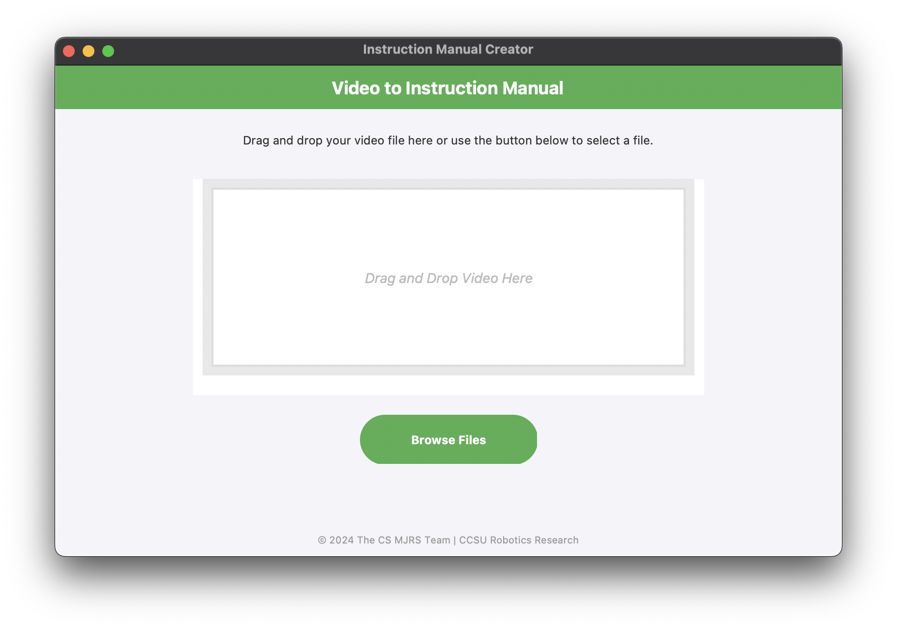
- Once you select the video file you want to process, confirm this is the correct file. If so, click “Process Video.” If not, click “No, Back to Main Page” and choose another file.
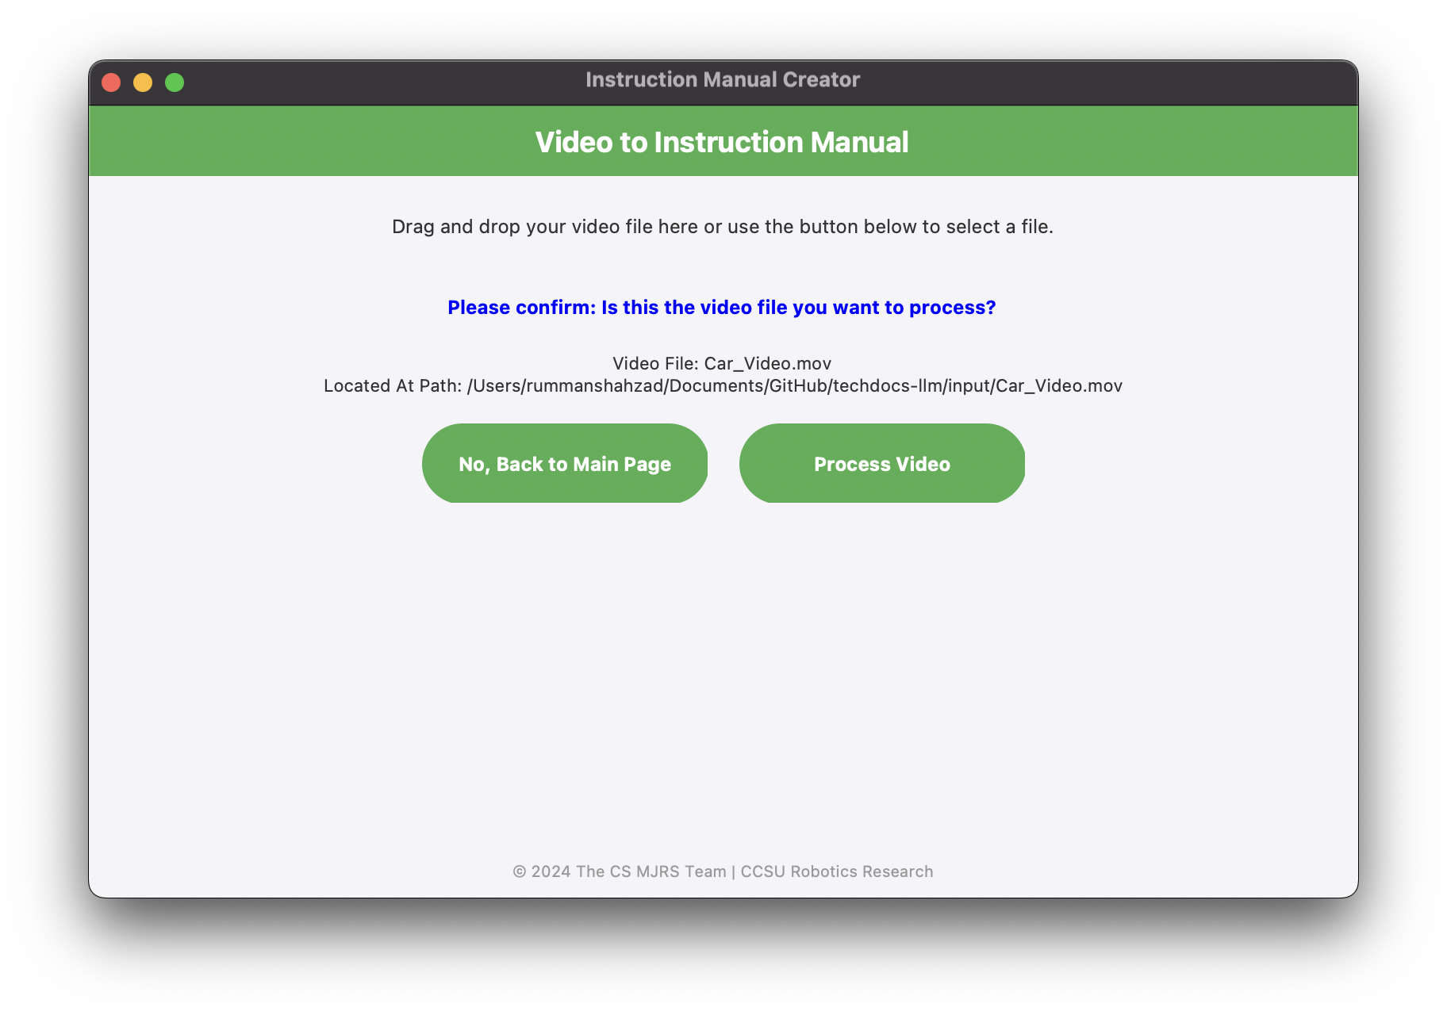
- Video processing will now begin. The GUI will hang and your cursor will show a loading icon. However all processing updates and steps will be displayed in the PyCharm console or system terminal/command processor (depending on how you executed the program), as shown below. Wait until processing finishes; this can take several minutes.
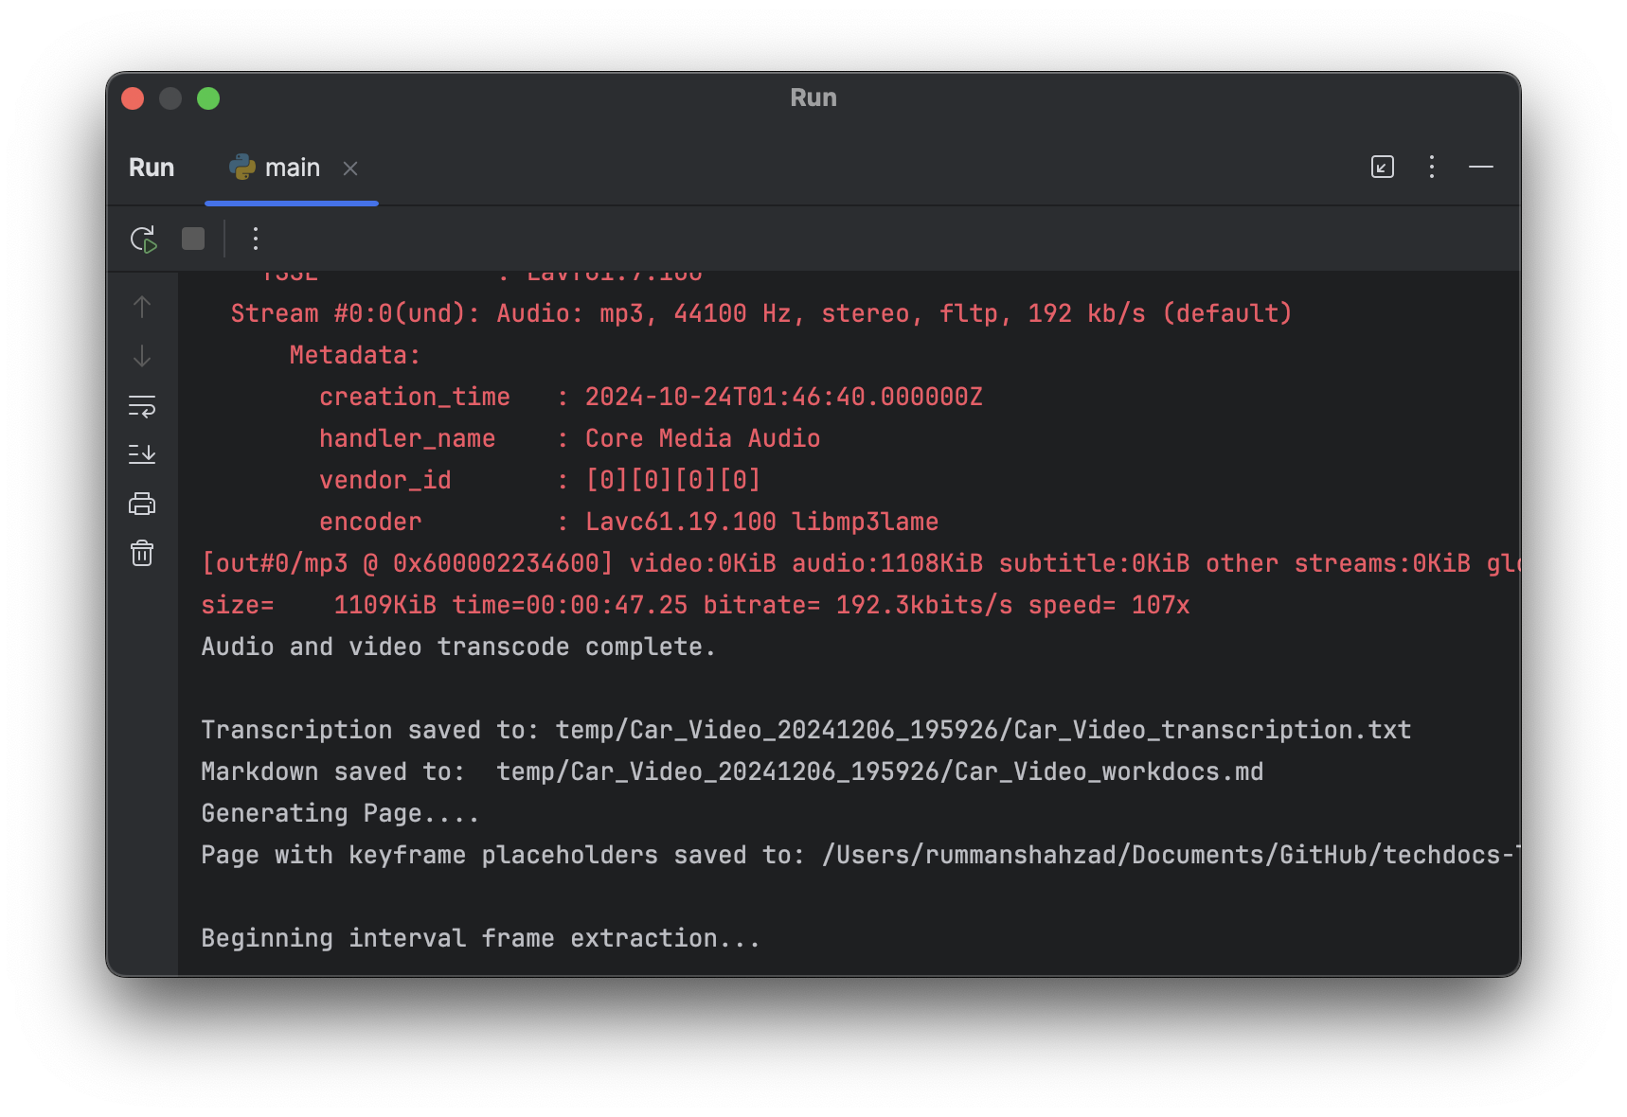
- Once complete, the system will alert you that video processing is finished. The file path of the generated documentation will be displayed. Be sure to move the generated documentation files and keyframes outside of the /output directory!
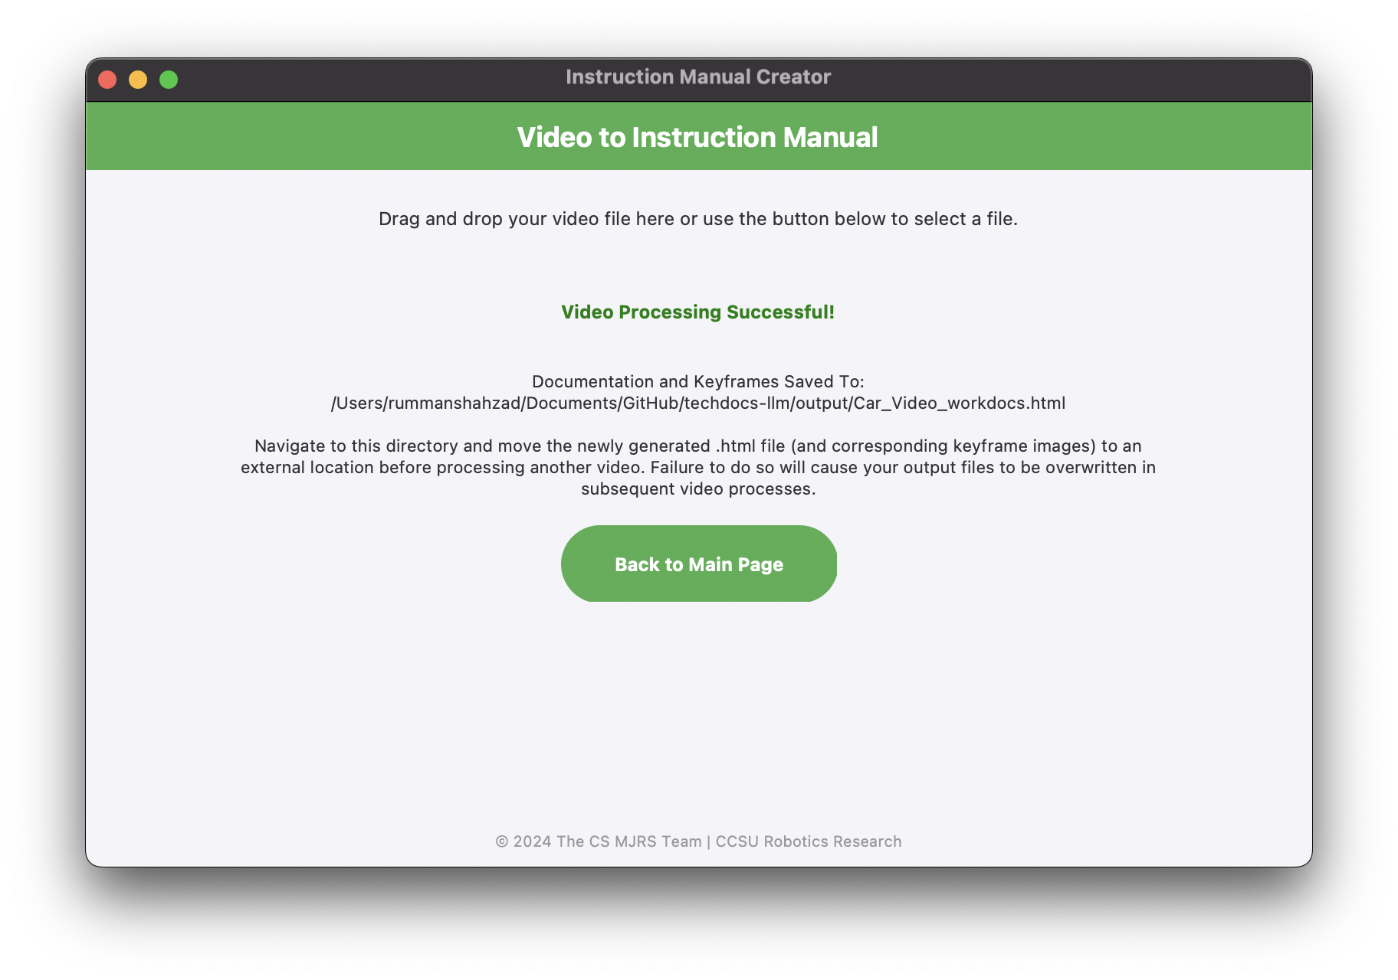

Part 4 - Additional Possible Scenarios

Below are some other scenarios that might occur when using the system.

a. Invalid File Input (Drag + Drop):
- If the user drags and drops a file that is not a video file, the system will reject that input.

- The user drags and drops an invalid file (extensions other than .mov, .mp4, .mkv, .avi)
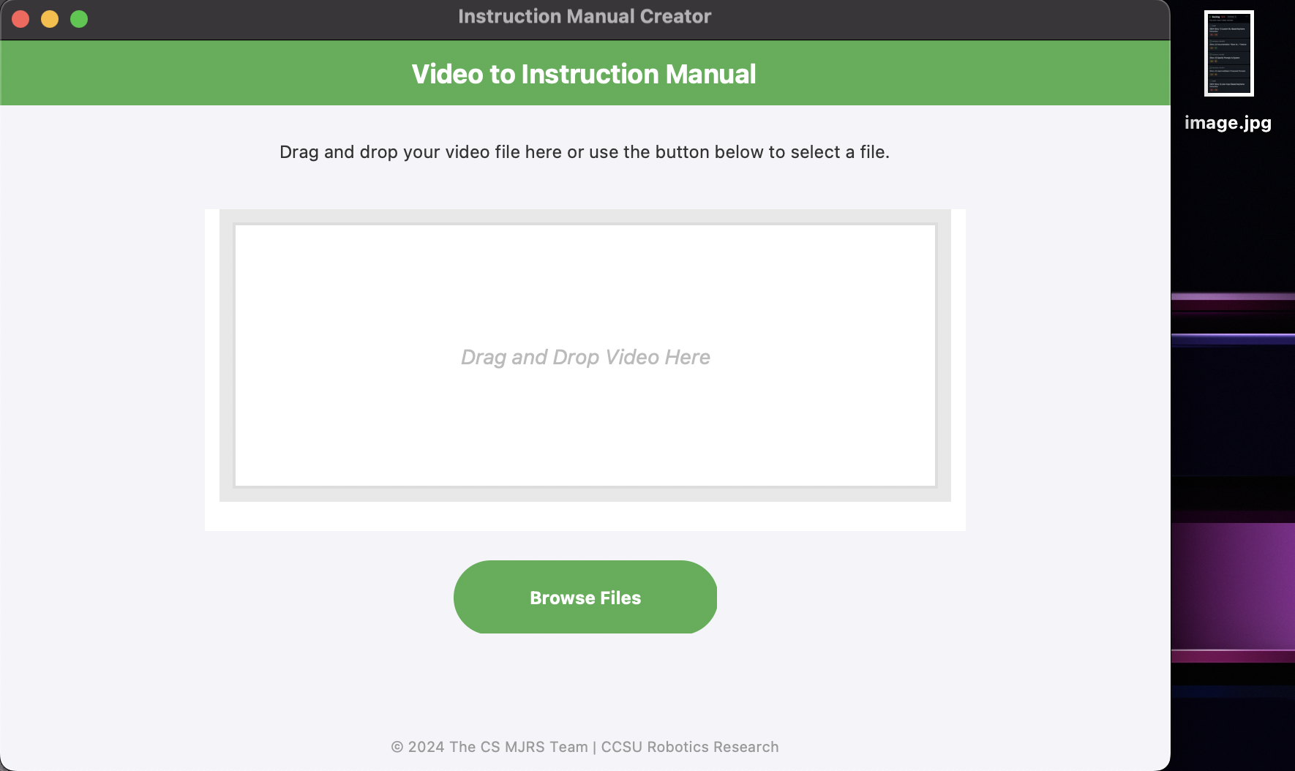

- The GUI then presents a warning message to use the correct file type and a button to go back to the main page.
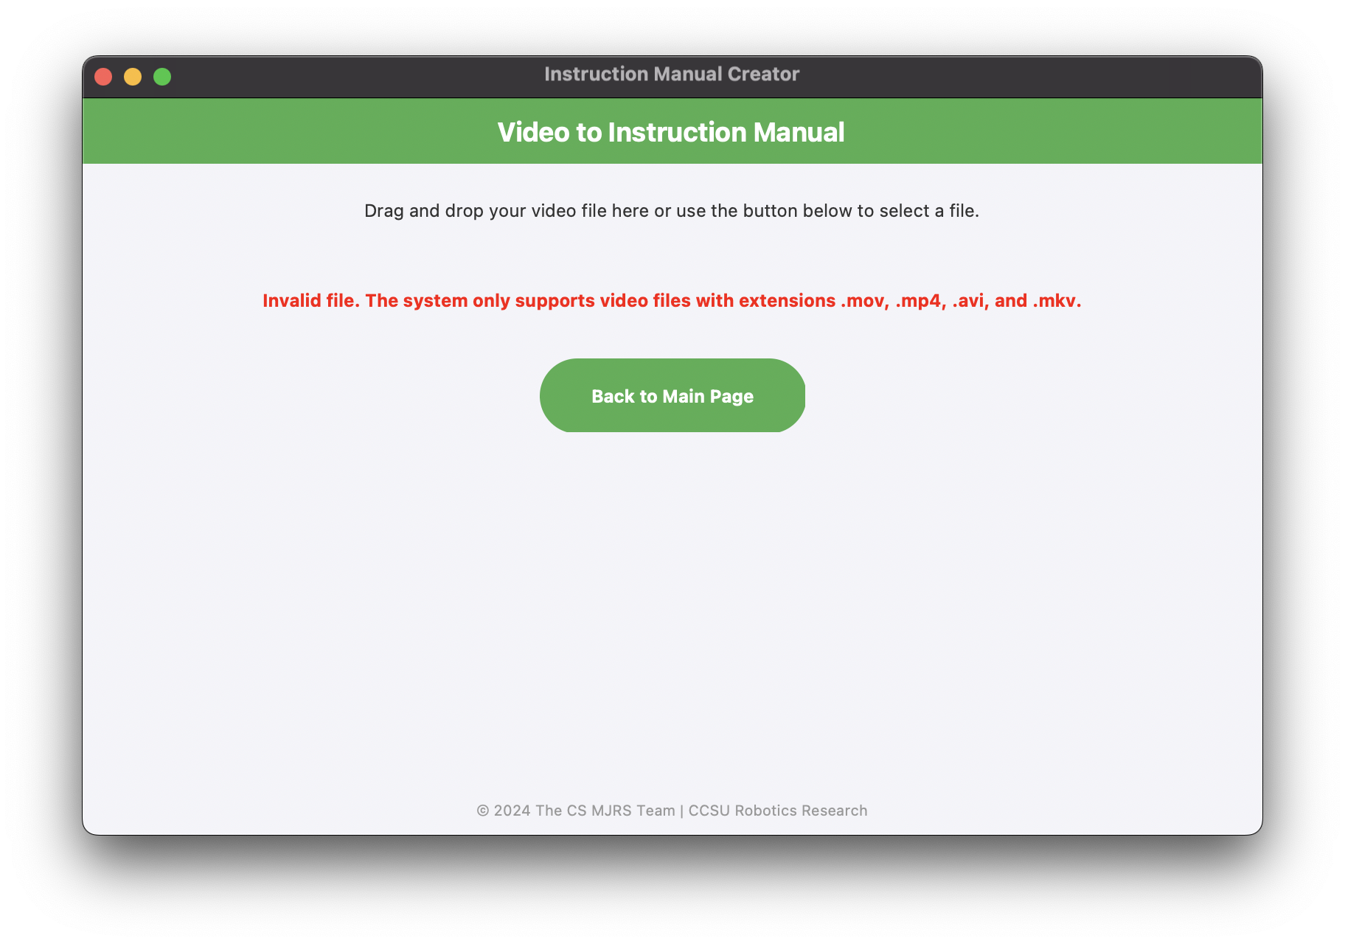
- The user is brought back to the main page to upload a valid video.
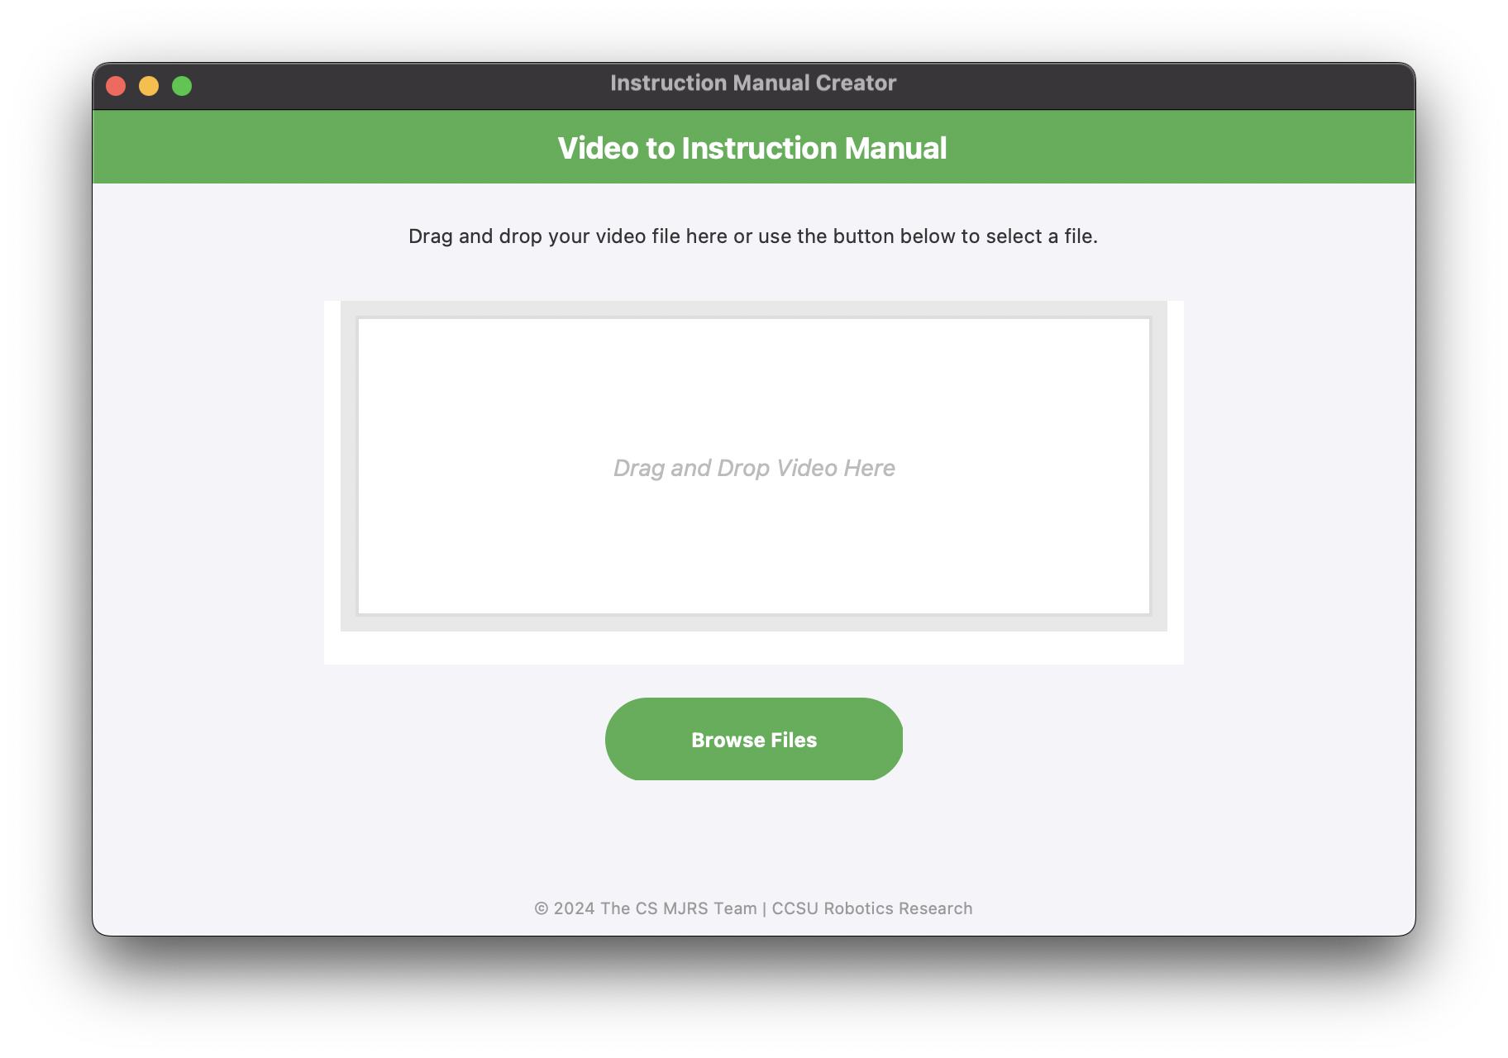

b. File Explorer Opened and No File Selected
- If the user opens the File Explorer (with the “Browse Files” button) and closes the File Explorer window without sending a video, the system informs the user that they must select a video.

- The user clicks “Browse Files” to open the operating system’s File Explorer.
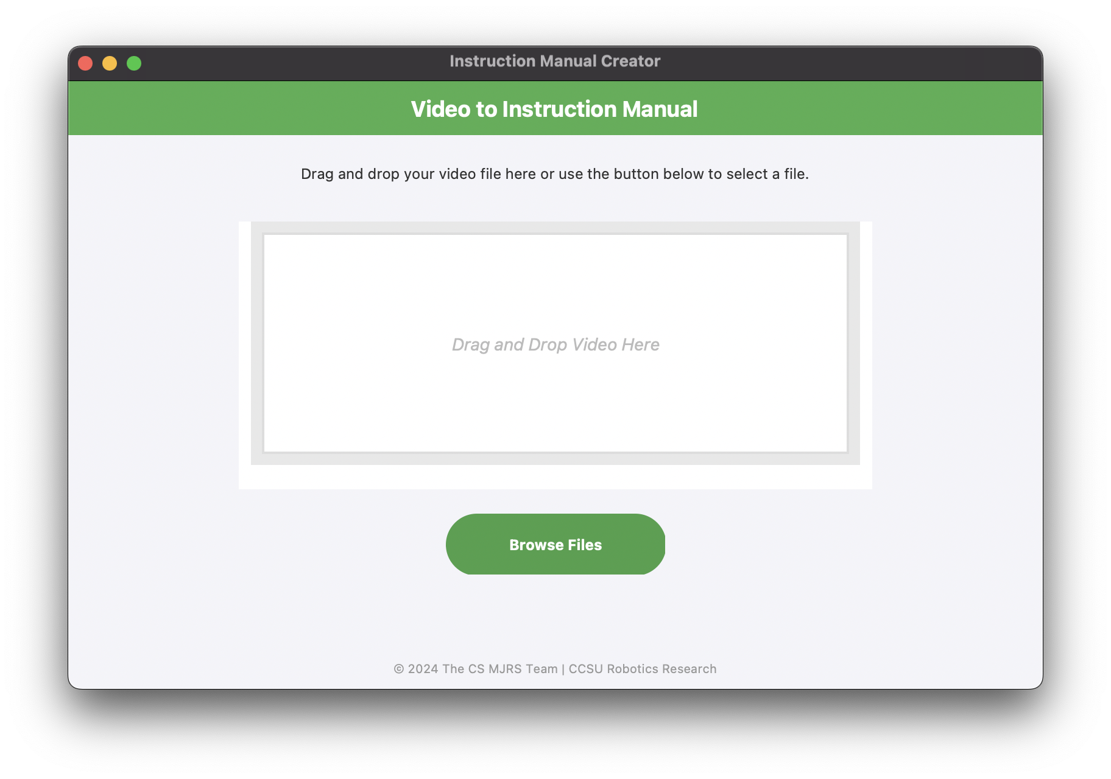

- The user hits “Cancel” or closes the File Explorer.
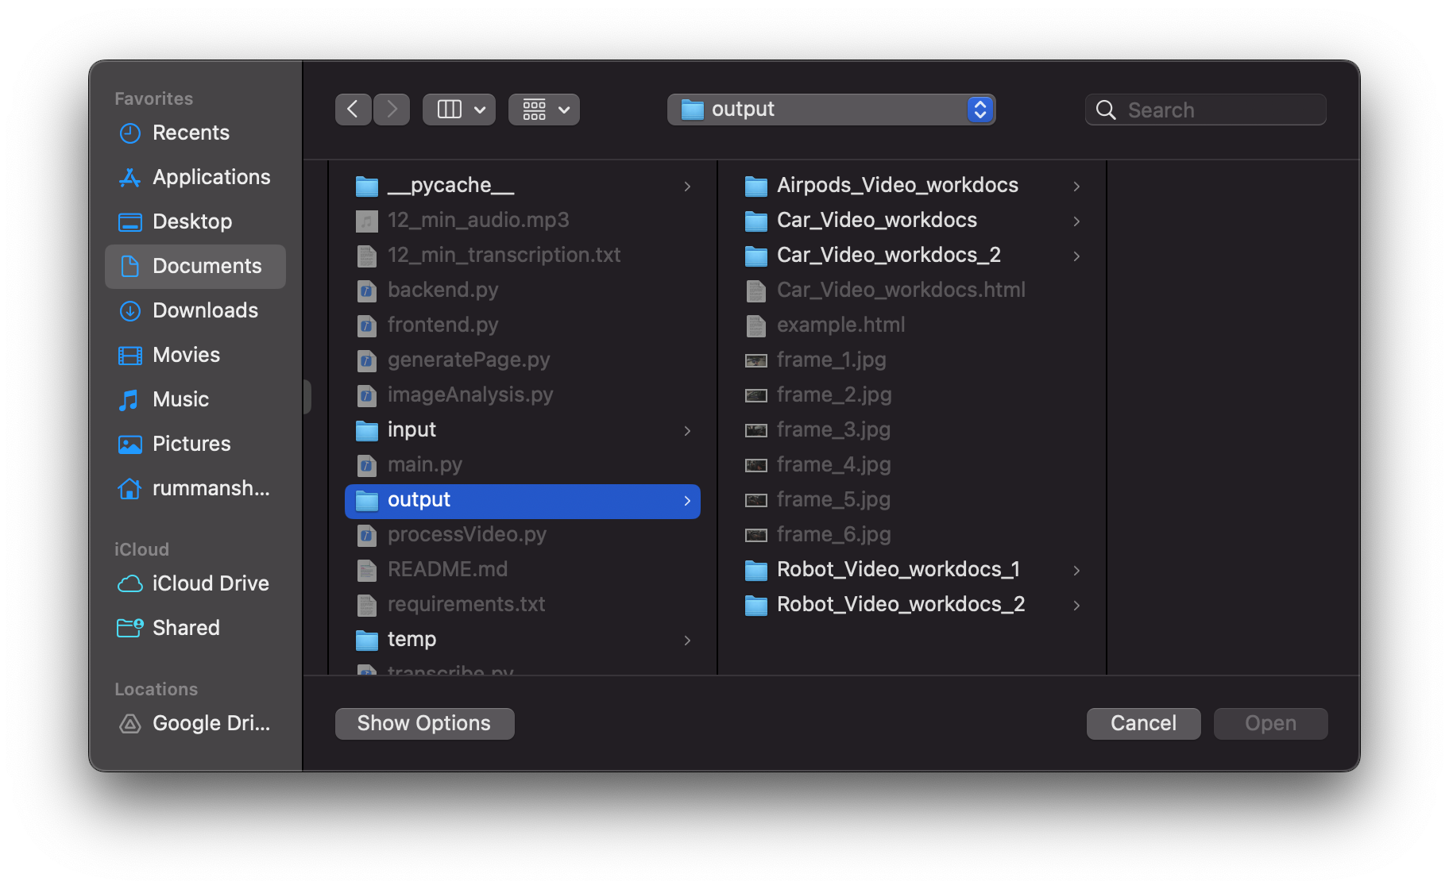

- The GUI presents a warning message and a button to go back to the main page.
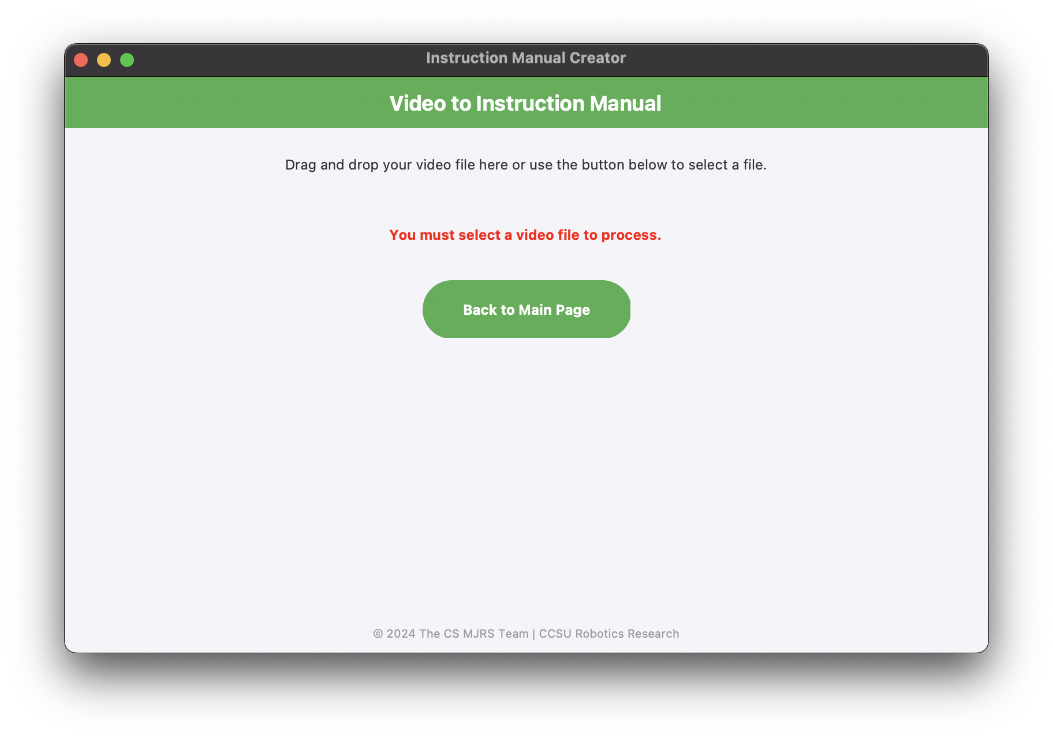

- The user is brought back to the main page to upload a valid video.


